The Research Paper… What Goes Where?

(This is not the template; the actual template is named T-23)

FIRST: You must make an appointment with the writing center to review your paper towards completion. Submit a screenshot of the Client Report Form to Canvas by or before the due date.

INTRODUCTION (2 pages)

Introduction to the topic
Grab the reader in… This section describes what the researcher will investigate and introduces the significance of the research by describing the study. This section should briefly identify issues related to the topic and or innovation in the field. What is your topic about? Are there any cool examples of your topic in use in the real world?

Background of the topic within society
The background section describes the history of the problem or topic. It provides a summary on the topic. Next, build an argument or justification for the current study by presenting a series of logical arguments, each supported with citations from the literature. Are there any important players (people/companies/dates) tied to your topic?

Relevance to society and ethics
This section establishes the importance of the topic and creates reader interest. It focuses the reader’s attention on how the study will add value to the field. Include at least two references from your literature review in this area. Discuss who is affected and who the topic benefits/hurts. What are the legal, political, social, or economic implications surrounding your topic?

Statement of the problem or thesis
This should include a clear statement that the problem exists, evidence that supports the existence of the problem, evidence of an existing trend that has led to the problem, or a statement positioning the writer for/against the topic or any aspect of the topic. Create a sentence that begins with “The purpose of this study is . . .” Clearly identify the area of conflict, concern, or controversy. (See help)

LITERATURE REVIEW (3 pages or so…)

Literature on the topic
This chapter presents the framework for the study. To perform significant research, the learner must first understand the literature related to the research focus. A well-articulated, thorough literature review provides the foundation for a substantial research. A literature review is a synthesis of what has been published on a topic by researchers. Include a total of 4 different pieces of literature in this paper. (See help)
You can either do a literature review by source (each section is about only one article/piece of research) or by concept (each section is about a concept tied to your topic with multiple sources interwoven throughout). See “Organizing the Body” in the link above.

DATA (1 page)

Original data collection
In this section, you will be detailing the steps you took to create and disseminate your data collection. If you chose the survey method, What platform did you use (Google Forms, Survey Monkey, etc.)? How did you send out your survey (through friends, family, social media, etc.)? Did you perform an interview and with whom? How many questions did you ask and what were they?
Do not include names or identifiers or any information at all about the people you survey. For this study use the qualitative methodology that uses data sources from survey instruments. These data sources may include paper surveys (no names), interviews, or observations. Researchers must develop their own interview or focus group, observation checklist, when conducting this qualitative study.
You get to ask what you want so long as its related to your topic. Be creative!

Data Analysis
In this second part, you will be connecting the result of your data collection to your topic (especially concerning ethics!) Talk about the types of responses you received and what these responses mean for your topic. Did people respond favorably to your topic? Are there widespread ethical concerns about your topic? Do people have any recommendations or requirements concerning your topic’s use in the real world?
Screenshots of the data collection should be included in the Appendix (NOT the text) and they should be titled (ex. Figure 1) so they can be referred to in this section.

CONCLUSIONS AND REACTION (2 pages)
Ethical issues that exist for society
This section should describe what happened because of this research. It also tells the reader what the research implies for the future. The section provides new insights derived from the research to solve real and significant ethical problems.

Conclusion / Summary / Recommendations
This section reminds the reader of the importance of the topic and briefly explains how the study intended to contribute to the body of knowledge on the topic. It informs about the conclusions, data, and recommendations. Make sure to rearticulate your thesis as well as how the research you presented supports this stance.

REFERENCES
(See help)

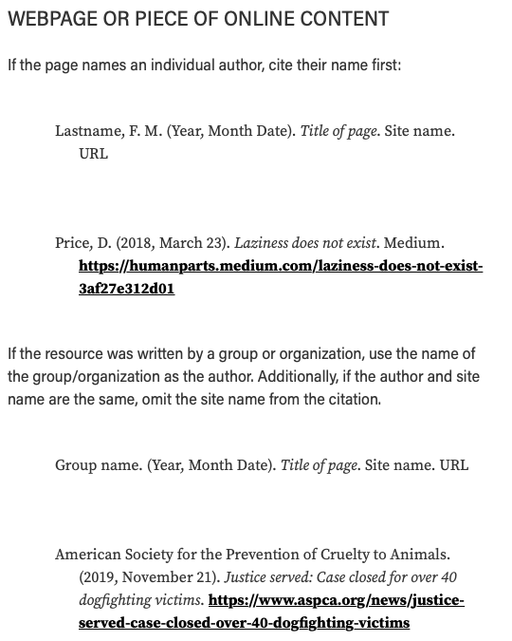

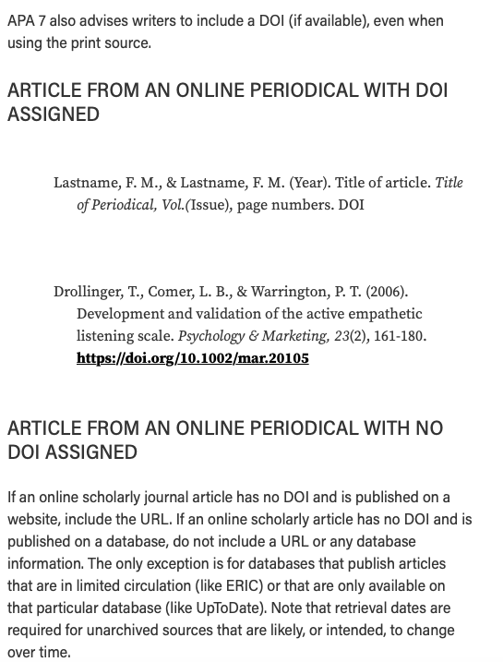

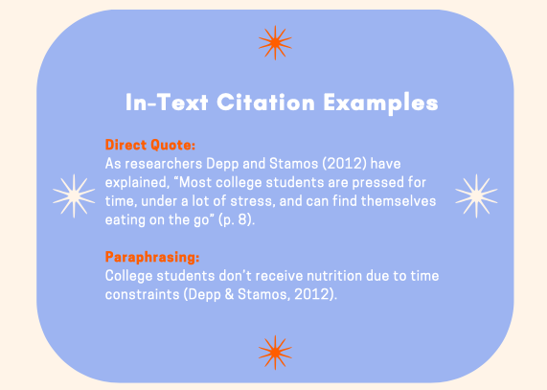

Appendix A
Data Analysis and Instrument

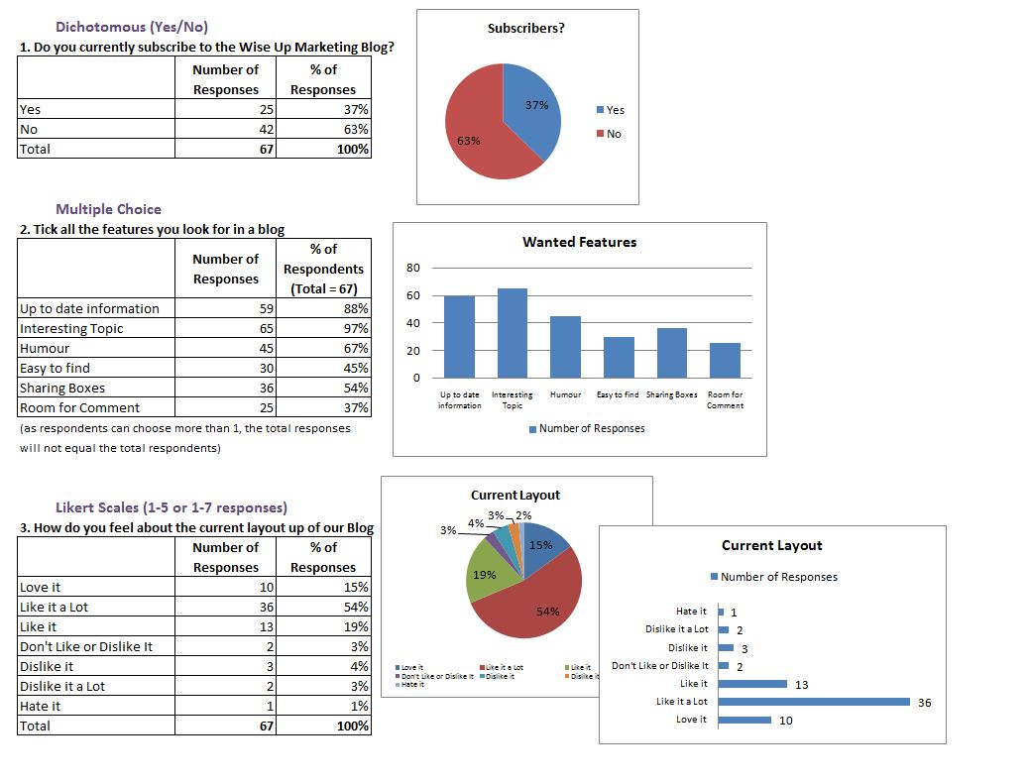

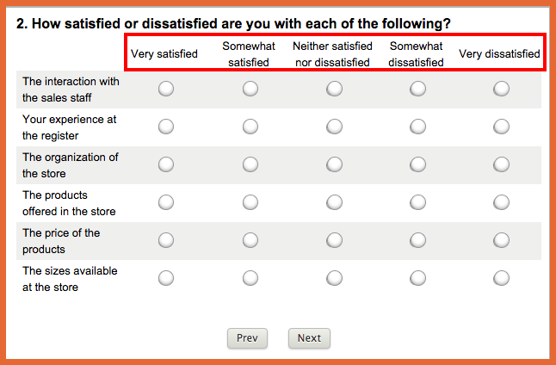
Figure 1.0 Shopping Experience Survey

